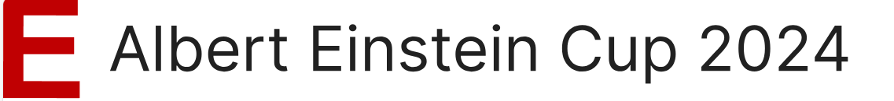

**Style Guide**

**1 Colors**

# https://lh3.googleusercontent.com/kIi7eCsBS3FlT-uI06JQcG_RlACYjhDl-msQOlEgHci2Gmcq7WKIaeTxBG4qT_jVlhvIB61xhgUByFxfoYKDuUKo1OZnhUtqtpK9TrhLNMUp9yeFiLRMX8xsicAKsQRpHqjbzFag15hay9QSrQ

|  |  |  |  |  |  |  |
| --- | --- | --- | --- | --- | --- | --- |
| **Blue** | **Khorne Red** | **Alert Red** | **Honey Yellow** | **Vivid Orange** | **Mystic Maroon** | **Mint Green** |
| #246eb9 | #6D0000 | #e23c12 | #ffb400 | #fe5f00 | #aa4b77 | #d7edd4 |
| Primary | Secondary | Error | Other | | | Background |

Blue and Khorne Red must be present on every screen (not counting the logo), except dialogs.

All backgrounds must be coloured in one of the colours above. Mint Green may be used for any background, whereas the other colours may only be used for small portions of the screen, e.g., for a header. Text fields may also have a white background.

All alerts and errors must be coloured in Alert Red. Colours in the category “Other” can be used for small supplemental elements, diagrams, and visualizations.

The Style Guide should be minded for all windows, apps and documents.

# 2 Fonts

All text must use the font ***Verdana***.

Verdana

ABCDEFGHIJKLMNOPQRSTUVWXYZ

abcdefghijklmnopqrstuvwxyz

# 3 Logo



The logo must be present on every screen, including dialogs. It must be large enough so that the letters “E A NB” remains readable. It may only be used on white or Mint Green backgrounds. The spacing on all sides must be at least as large as the letter “N” is tall.